Subject: Programming with Java
ASSIGNMENT No : 7
TITLE :Implement a Java program to demonstrate inheritance and interfaces using suitable real-world examples.
Name: Avdhoot Mohite Class:CSE A3
PRN:25070122056 Batch: 25-29
Problem Statement
Implement a Java program to demonstrate inheritance and interfaces using suitable real-world examples.
Learning Objectives
To implement inheritance and interfaces for achieving code reusability and abstraction.
Theory
Inheritance allows one class to acquire the properties and methods of another class, promoting code reuse and reducing redundancy. Java supports single inheritance through the extends keyword. Interfaces define a contract that implementing classes must follow, enabling abstraction and multiple inheritance of type. Together, inheritance and interfaces support polymorphism and modular software development. They are fundamental concepts of object-oriented programming.

Outcome
After completing this experiment, we learned how to implement inheritance and interfaces in Java. We understood how inheritance promotes code reusability by allowing child classes to inherit the properties and methods of a parent class, while interfaces provide abstraction by defining a common set of methods that implementing classes must follow. The experiment improved our understanding of object-oriented programming concepts and their real-world applications.
Conclusion
The experiment successfully demonstrated the implementation of inheritance and interfaces using real-world examples. Inheritance helped in reducing code redundancy and improving reusability, while interfaces provided abstraction and ensured a common structure for different classes. These concepts are essential for developing modular, maintainable, and scalable object-oriented Java applications.
Exercise
1.Create a Shape application where Circle and Rectangle inherit from Shape and calculate area
Code:
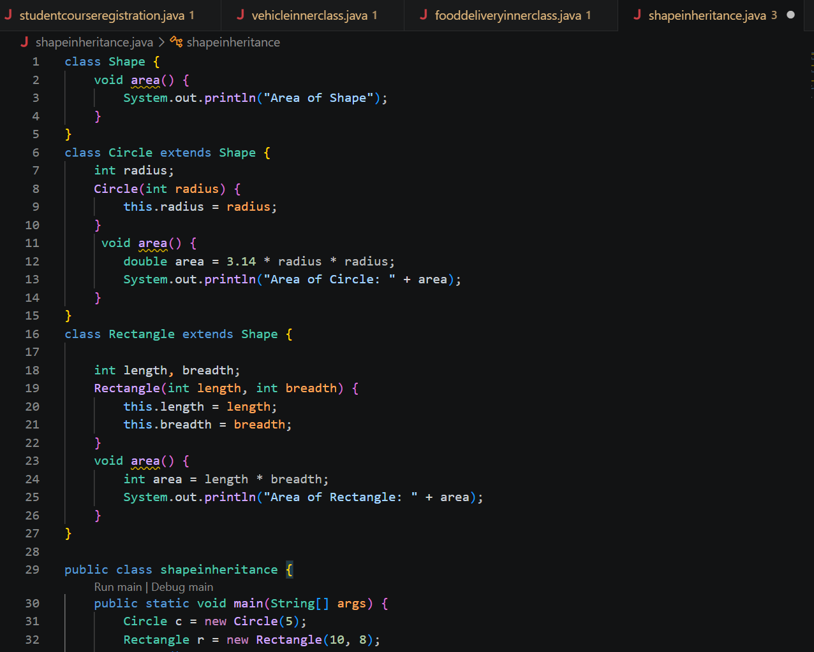
Output:
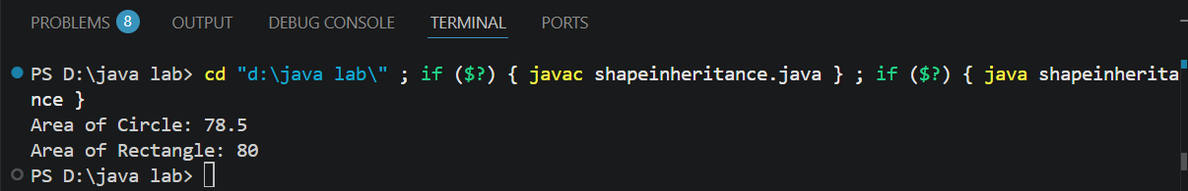

2. Develop a E-Commerce Product System where electronic, clothing, and grocery products inherit common properties and implement product interfaces.
Code:
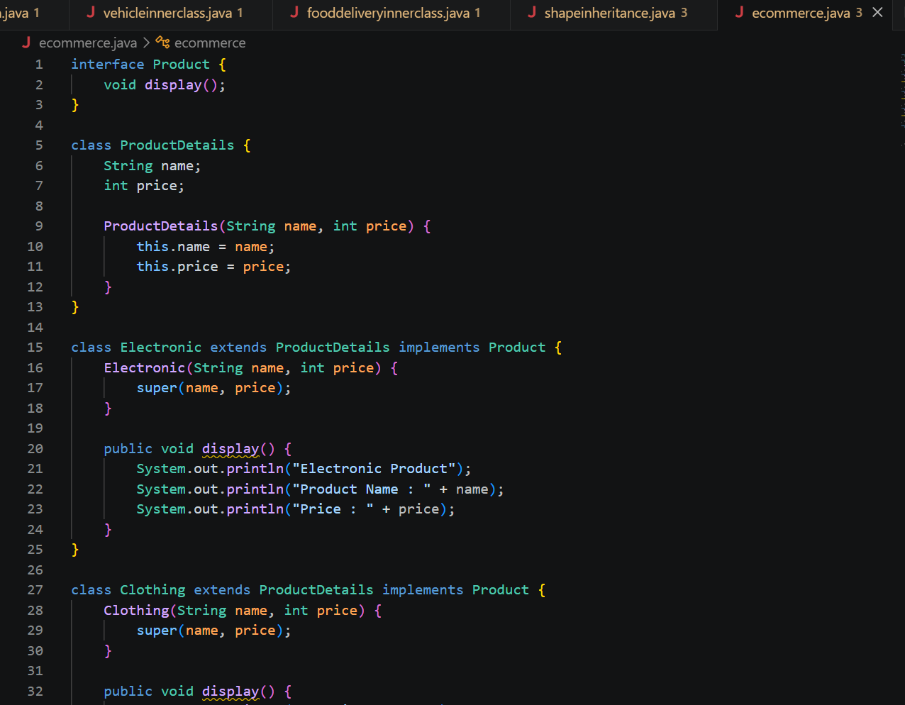
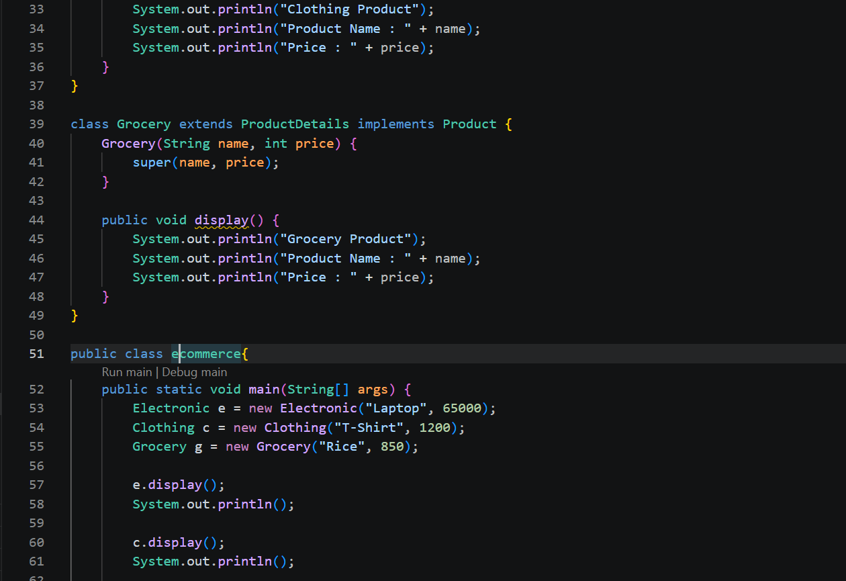

Output:
